**Introduction**: In this document report, we present the different models created to predict Life Expectancy of a country’s population based on different variables ranging from immunization factors, mortality factors, economic factors, social factors and other health related factors. We also dive deep into some variables which strongly influence Life Expectancy of a country’s population.

**Data Description:** The data set we have captures 22 columns for 193 countries from year 2000-2015 over 2938 rows. The data set has 20 predicting variables. Some of the variables that we will be talking about throughout our analysis are listed below:

Life expectancy – Life Expectancy in age.

Status- Developed or Developing status of a country.

percentage expenditure- Expenditure on health as a percentage of Gross Domestic Product per capita (%).

Total expenditure- General government expenditure on health as a percentage of total government expenditure (%)

GDP- Gross Domestic Product per capita (in USD)

Population- Population of the country

Income composition of resources: Human Development Index in terms of income composition of resources (index ranging from 0-1)

Schooling- Number of years of Schooling (years).

Adult Mortality - Adult Mortality Rates of both sexes (probability of dying between 15 and 60 years per 1000 population)

Alcohol- Alcohol, recorded per capita (15+) consumption (in liters of pure alcohol).

Immunizations- Data around Polio, Measles, Hepatitis B and Diphtheria.

HIV/AIDS- Deaths per 1 000 live births HIV/AIDS (0-4 years).

thinness 1-19/ 5-9 years - Prevalence of thinness among children and adolescents for Age 10 to 19 (%) and 5-9 years as well.

BMI: Average Body Mass Index of entire population

infant deaths: Number of Infant Deaths per 1000 population

under-five deaths: Number of under-five deaths per 1000 population

**Analysis:**

We have data for 193 countries, out of which 161 are categorized as ‘developing’ status and 32 are categorized as ‘developed’ status. Looking at Life Expectancy variation by ‘Status’, we see that there is a clear distinction between the Life expectancy of country’s population by its ‘Status’.

**Figure 1**

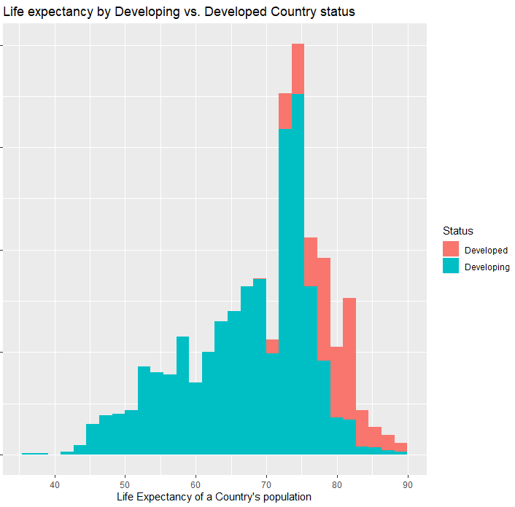

**Correlation:**

Variables that have significant correlation with Life Expectancy: Schooling(0.7276), Income_composition_of_resources(0.7211) , Adult Mortality (-0.7025), HIV_AIDS( -0.5922), BMI(0.5420), thinness_1_19_years(-0.4578), thinness_5_9_years(-0.4575) ), GDP(0.4413), percentage_expenditure(0.4096), Alcohol (0.4027), Diphtheria(0.3413 ) and Polio(0.3273).

Variables that are highly correlated to each other: infant_deaths and under_five_deaths at 0.9969; GDP and percentage_expenditure at 0.9593; thinness_5_9_years and thinness_1_19_years at 0.9279; Schooling and Income composition of resources at 0.7847.

Objective 1: Build and compare data models to predict life expectancy of a country’s population.

1. Simple and highly interpretable model:

**Model** 1: Building model 1 using variables with correlation with Life Expectancy. Running GLM, variable Alcohol proves to be statistically insignificant. Thus, it was removed from the model.

Life_Expectancy = $β0$ + $β1Adult_Mortality$ + $β2HIV_AIDS$ + $β3BMI$ + $β4thinness_1_19_years$ + $β5GDP$ + $β6Diphtheria$ + $β7Polio$ + $β8Schooling$

**Model 2**: Model 1 is a simple and highly interpretable model, but looking at the residual plots (please refer to page 23), it can be improved by adding log transforms to Life expectancy, GDP and $HIV_AIDS$.

After adding log transforms, BMI became statistically insignificant, so it was removed from the model.

Please refer to page 24 for Model 2 residual plots.

Log_Life_Expectancy = $β0$ + $β1Adult_Mortality$ + $β2log_HIV_AIDS$ + $β3thinness_1_19_years$ + $β4log_GDP$ + + $β5Diphtheria$ + $β6Polio$ + $β7Schooling$

Comparing the PRESS Statistic (CV) and R-sq for both the models.

|  |  |  |  |
| --- | --- | --- | --- |
| **Model** | **PRESS STATISTC (CV)** | **R-sq** | **Adj R-sq** |
| Model 1 | 41012.174 | 0.8218 | 0.8212 |
| Model 2 | 8.48 | 0.8454 | 0.8449 |

Fitting model 2: As Model 2 has significantly lower PRESS Statistic, Model 2 is considered better.

Mean(Log_Life_Expectancy|=

3.972903921-0.000230961*Adult_Mortality -0.041370168log_HIV_AIDS - 0.002062371* thinness_1_19_years **+** 0.007546849*log_GDP **+** 0.000397376*Diphtheria **+** 0.000213914*Polio **+** 0.012198913*Schooling

1. Interpretation: According to Model 2, Life_Expectancy of a country’s population is related to the following variables in below described ways:

Though, it is not practical, but if all the factors considered on this model are 0, Life Expectancy of a country’s population will e3.972903921 = 53.13.

Adult_Mortality: Keeping all other factors constant, it is estimated that, a one unit increase in Adult_Mortality is associated with a ( $e^{-0.000230961}$ = 0.999769066) 0.023% decrease in median Life_Expectancy. 95% confidence interval for this decrease is between ( $e^{-0.000206568}$ = 0.999793) 0.021% and ( $e^{-0.000255354}$ = 0.999744679) 0.026%.

HIV_AIDS: Keeping all other factors constant, it is estimated that, a doubling of HIV_AIDS is associated with a $(2^{- 0.041370168}$ =0.959473898) 4.053% decrease in median Life_Expectancy. 95% confidence interval for this decrease is between ( $2^{-0.039309427}$ = 0.961453) 3.855% and ( $2^{-0.04343098}$ = 0.957498707) 4.25%.

thinness_1_19_years: Keeping all other factors constant, it is estimated that, a one unit increase in thinness_1_19_years is associated with a ( $e^{-0.002062371}$ = 0.997939754) 0.206% decrease in median Life_Expectancy. 95% confidence interval for this decrease is between ( $e^{-0.001466004}$ = 0.99853507) 0.146% and ( $e^{-0.002658737}$ = 0.997344794) 0.266%.

GDP: Keeping all other factors constant, it is estimated that, keeping all other factors constant, a doubling of GDP is associated with a $(2^{0.007546849}$ =1.007575398) 0.758% increase in median Life_Expectancy. 95% confidence interval for this decrease is between ( $2^{0.0059571}$ = 1.005974879) 0.597% and ( $2^{0.009136598}$ = 1.009178464) 0.918%.

Diphtheria: Keeping all other factors constant, it is estimated that, Keeping all other factors constant, a one unit increase in Diphtheria is associated with a ( $e^{0.000397376}$ = 1.000397455) 0.04 % increase in median Life_Expectancy. 95% confidence interval for this decrease is between ( $e^{0.000258171}$ = 1.000258204) 0.026% and ( $e^{0.000536581}$ = 1.000536725) 0.054%.

Polio: Keeping all other factors constant, it is estimated that, Keeping all other factors constant, a one unit increase in Polio is associated with a ( $e^{0.012198913}$ = 1.000213937) 0.021 % increase in median Life_Expectancy. 95% confidence interval for this decrease is between ( $e^{0.000074262}$ = 1.000074265) 0.007% and ( $e^{0.000353565}$ = 1.000353628) 0.035%.

Schooling: Keeping all other factors constant, it is estimated that, Keeping all other factors constant, a one unit increase in Schooling is associated with a ( $e^{0.012198913}$ = 1.012273623) 1.227 % increase in median Life_Expectancy. 95% confidence interval for this decrease is between ( $e^{0.011117162}$ = 1.011179187) 1.18% and ( $e^{0.013280664}$ = 1.013369244) 1.337%.

1. Complex model (Model3): After running feature selection techniques and adding interaction with the variable ‘Status’, below is the model that we have created:

Log_Life_Expectancy(for Countries with Status=’Developing’) = $β0$ + $β1log⁡_HIV_AIDS+ β2Schooling$ + $β3Adult_Mortality$ + $β4Income_composition_of_resources$ + $β5log_percentage_expenditure$ + $β6Diphtheria$

Log_Life_Expectancy(for Countries with Status=’Developed’) = $β0$ + $β1log⁡_HIV_AIDS+ β2Schooling$ + $β3Adult_Mortality$ + $β4Income_composition_of_resources$ + $β5log_percentage_expenditure$ + $β6Diphtheria$ + $β7Income_compos*Status Developed$

**Comparing models**

Comparing the PRESS Statistic (CV) and R-sq for model 2 and Model 3.

|  |  |  |  |
| --- | --- | --- | --- |
| **Model** | **PRESS STATISTC (CV)** | **R-sq** | **Adj R-sq** |
| Model 2 | 8.48 | 0.8454 | 0.8449 |
| Model 3 (with interaction) | 7.78 | 0.8502 | 0.8497 |

ASE for Model 3: **ASE (Train)=** 0.00335 and **ASE (Test) =** 0.00333.

Model 3 is the preferred model for the following reasons:

1. From Figure 1, we can see that the ‘Status’ of a country strongly affects the Life expectancy of its population. Model 3 takes this into account.
2. Model 3 has better CV statistics, R-sq and Adjust R-sq.
3. Model 3 has fewer variables with log transforms, so it is easier to interpret.

**Fitting model 3:**

Mean(Log_Life_Expectancy{for Countries with Status=’Developing’}) = 3.972351146 $-0.041640209*log_HIV_AIDS*+ 0.008289124*Schooling$-0.000211583 $*Adult_Mortality$ + 0.104705191 $*Income_composition_of_resources$ + $0.006853873*log_percentage_expenditure$ + $0.000473442*Diphtheria$

Mean(Log_Life_Expectancy{for Countries with Status=’Developed’}) = 3.972351146 $-0.041640209*log_HIV_AIDS-+ 0.008289124*Schooling$ + $-0.000211583*Adult_Mortality$ + 0.104705191 + + +

2) Objective2 : KNN

**Final Conclusion:**

**Conclusion:**

**Factors where more time could have been spent:**

1. **Data Cleanse – Missing values could have been replaced by more sensible values.**
2. **Analyze other non-parametric models.**

Appendix:

LED <-read.csv(file.choose())

Reading the structure of the data

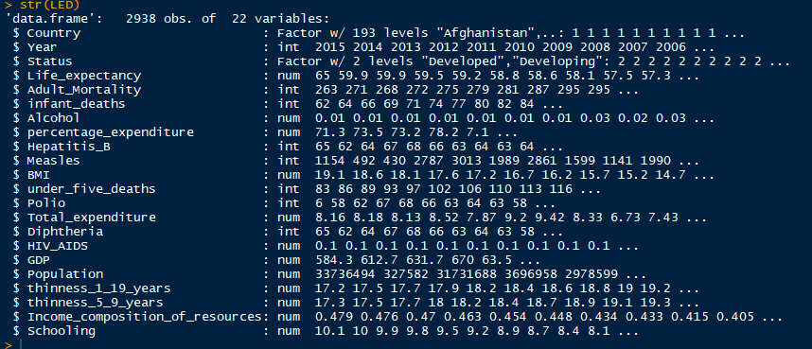

Reading the summary of the data

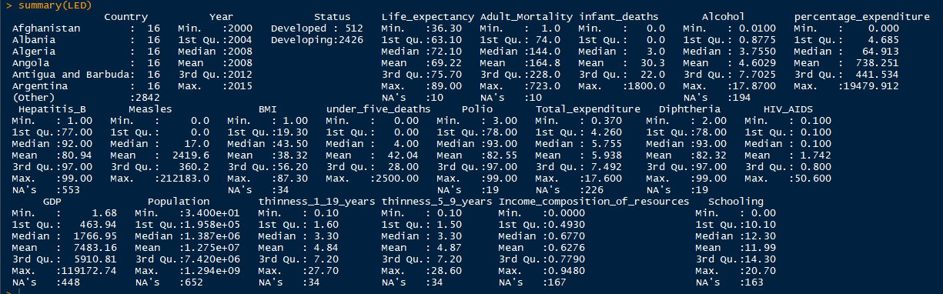

Some similar analysis in SAS

**proc** **means** data=LED n mean max min range std;

output out=meansout mean=mean std=std;

title 'Summary of LifeExpectancyData';

**run**;

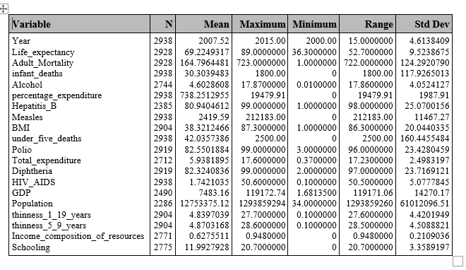

#Missing data

LED %>% filter(is.na(Life_expectancy))

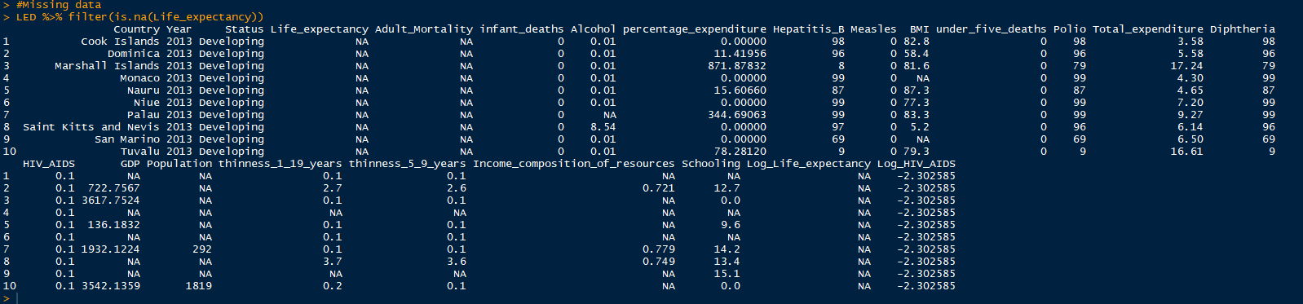





Scatter Plots:

plot(LED[,c(4,5,6,7,8,9,10,11)])

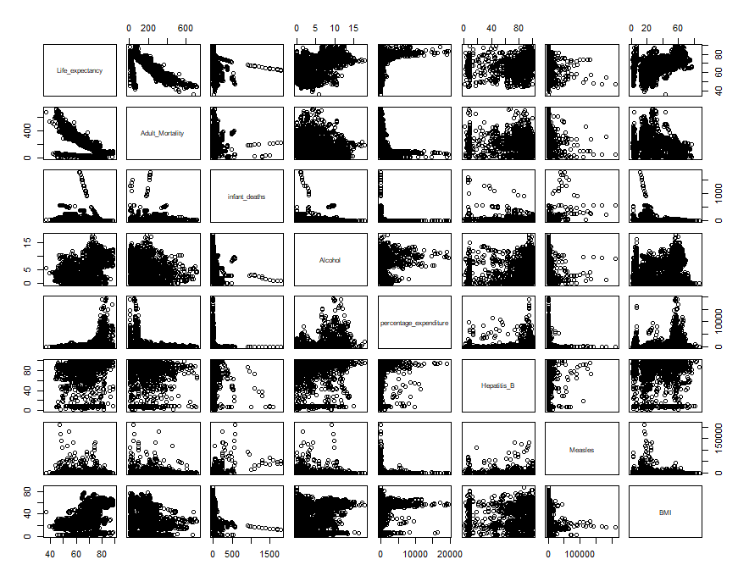

plot(LED[,c(4,12,13,14,15,16,17,18)])

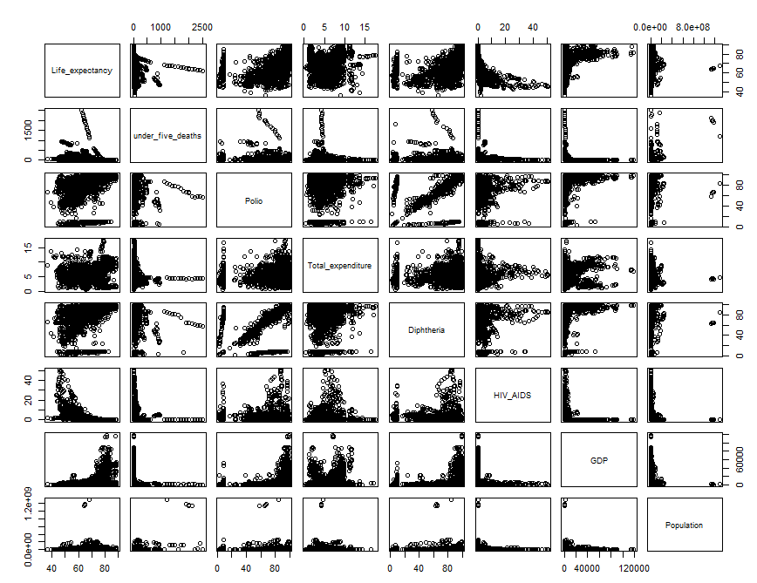

plot(LED[,c(4,19,20,21,22)])

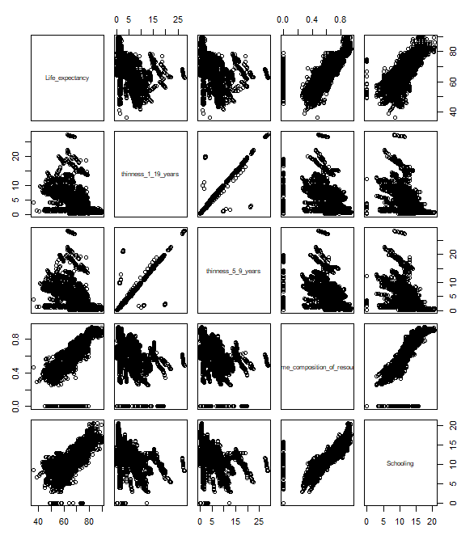

**Correlation:**

**proc** **reg** data=LED corr plots(label) = (rstudentleverage cooksd);

model Life_expectancy= Year Adult_Mortality infant_deaths Alcohol percentage_expenditure Hepatitis_B Measles BMI under_five_deaths Polio Total_expenditure Diphtheria HIV_AIDS GDP Population thinness_1_19_years thinness_5_9_years Income_composition_of_resources Schooling / VIF;

**run**; **quit**;

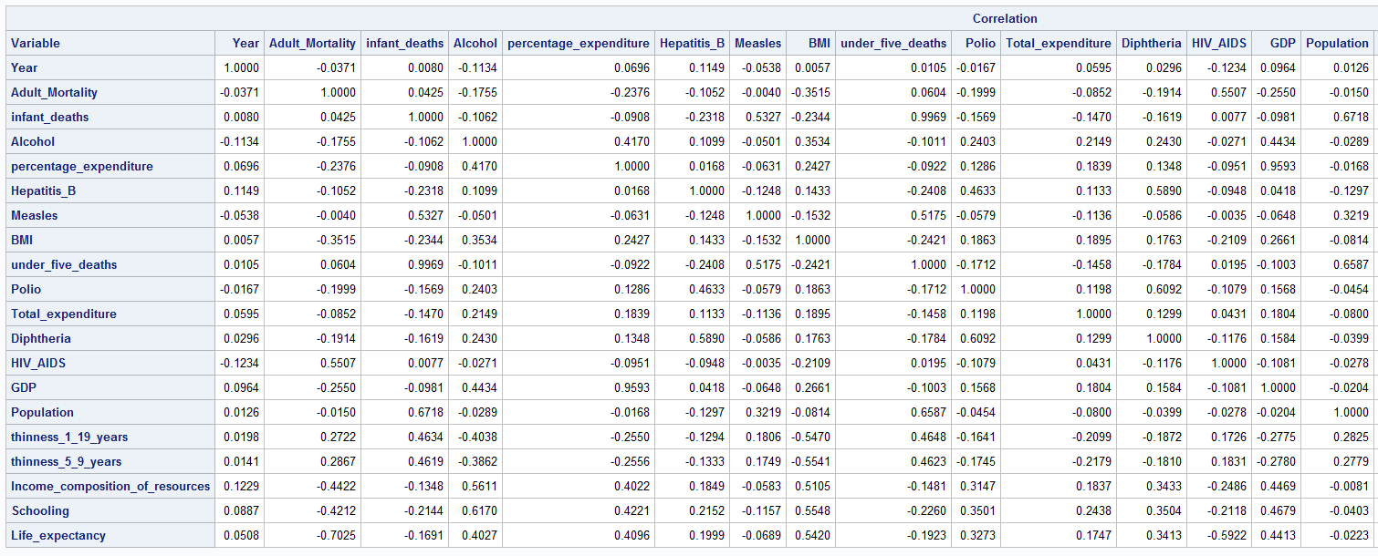

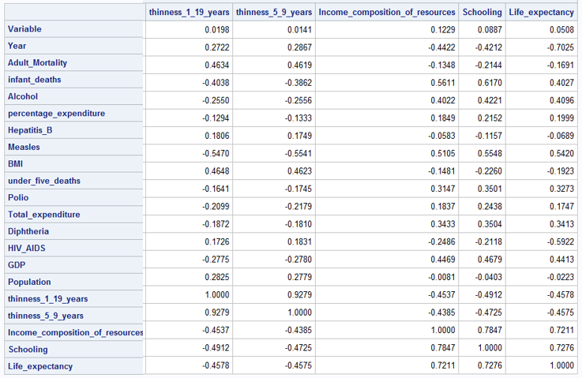

Models:

**proc** **reg** data=LED corr plots(label) = (rstudentleverage cooksd);

model Life_expectancy= Year Adult_Mortality infant_deaths Alcohol percentage_expenditure Hepatitis_B Measles BMI under_five_deaths Polio Total_expenditure Diphtheria HIV_AIDS GDP Population thinness_1_19_years thinness_5_9_years Income_composition_of_resources Schooling / VIF;

**run**; **quit**;

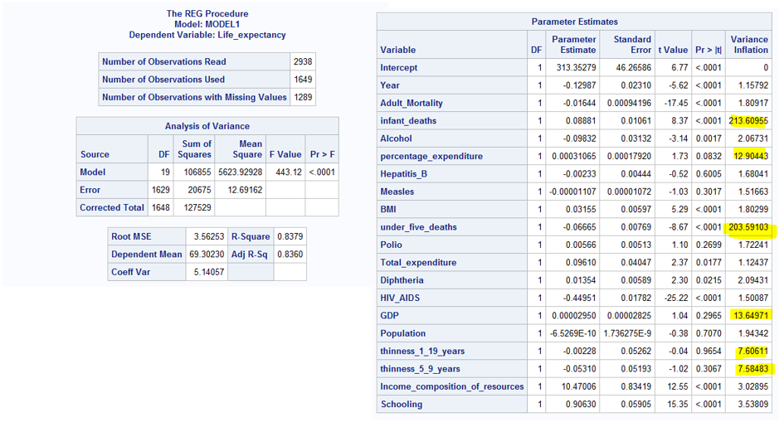

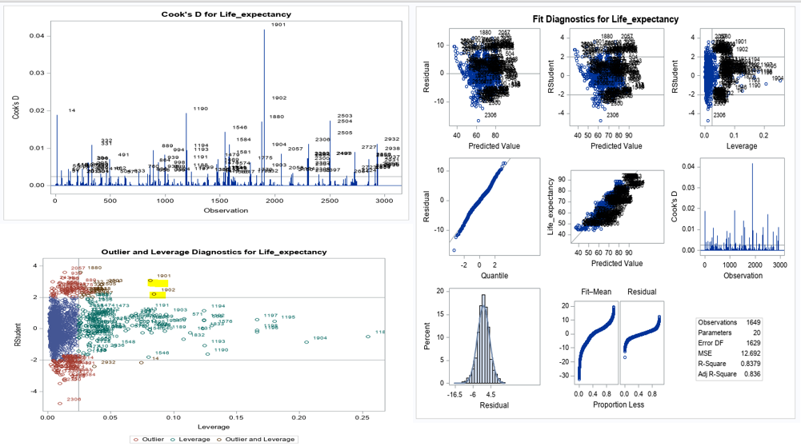

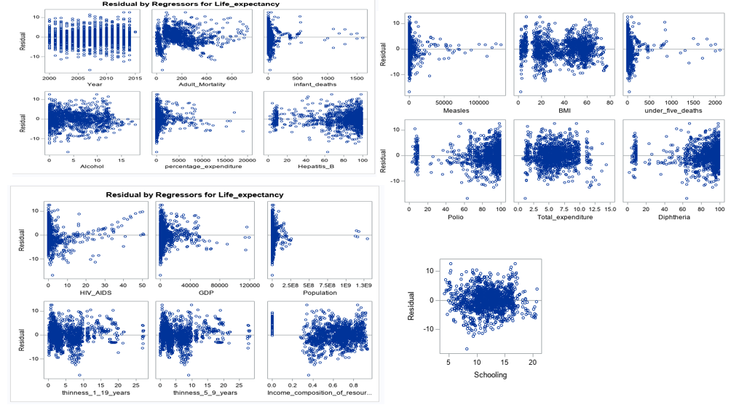

*Important observations;

*1) infant_deaths and under_five_deaths are highly correlated at 0.9969. Take infant_deaths out;

*2) GDP and percentage_expenditure are highly correlated at 0.9593. Take GDP out ;

*3) thinness_5_9_years and thinness_1_19_years 0.9279. Take thinness_5_9_years out;

*4) What do we do about under_five_deaths and Diphtheria? From VIFs, it looks like there's a correlation among these, but looking at the correlation factors above, we see it is -0.1784. So, we can keep them both in the model;

* Take infant_deaths,percentage_expenditure and GDP out and check VIFs;

**proc** **reg** data=LED corr plots(label) = (rstudentleverage cooksd);

model Life_expectancy= Year Adult_Mortality Alcohol percentage_expenditure Hepatitis_B Measles BMI under_five_deaths Polio Total_expenditure Diphtheria HIV_AIDS Population thinness_1_19_years Income_composition_of_resources Schooling / VIF;

**run**; **quit**;

* Looking at the residual plots, it feels necessary to do some transformations.;

**data** LED;

SET LED;

log_Life_expectancy = log(Life_expectancy);

log_percentage_expenditure = log(percentage_expenditure);

log_Adult_Mortality = log(Adult_Mortality);

log_Hepatitis_B = log(Hepatitis_B);

log_Measles = log(Measles);

log_BMI = log(BMI);

log_under_five_deaths = log(under_five_deaths);

log_Polio = log(Polio);

log_Total_expenditure = log(Total_expenditure);

log_Diphtheria = log(Diphtheria);

log_HIV_AIDS = log(HIV_AIDS);

log_Population = log(Population);

log_GDP = log(GDP);

**run**;

**proc** **reg** data=LED corr plots(label) = (rstudentleverage cooksd);

model log_Life_expectancy= Year Adult_Mortality Alcohol log_percentage_expenditure log_GDP Hepatitis_B log_Measles BMI log_under_five_deaths Polio Total_expenditure Diphtheria log_HIV_AIDS log_Population thinness_1_19_years Income_composition_of_resources Schooling / VIF;

**run**; **quit**;

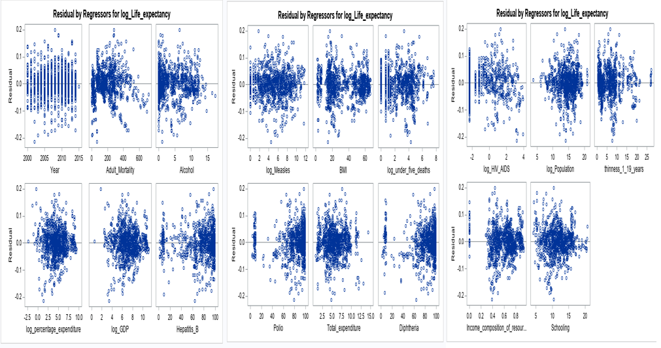

Model 1: Using variables with high correlation to Life_Expectancy

**PROC** **GLM** DATA= LED plots = all;

title "Model 1 WITH VARIABLES with correlation to Life_Expectancy ";

class Status;

model Life_expectancy = Adult_Mortality HIV_AIDS BMI thinness_1_19_years GDP Alcohol Diphtheria Polio Schooling / solution ;

output out = Customsel ;

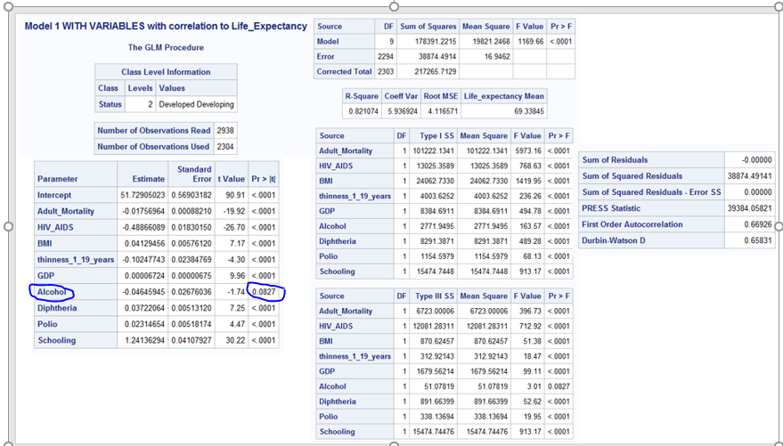

Variable Alcohol being statistically insignificant, removing it from the model.

**Revised Model1**

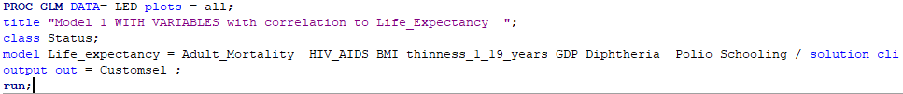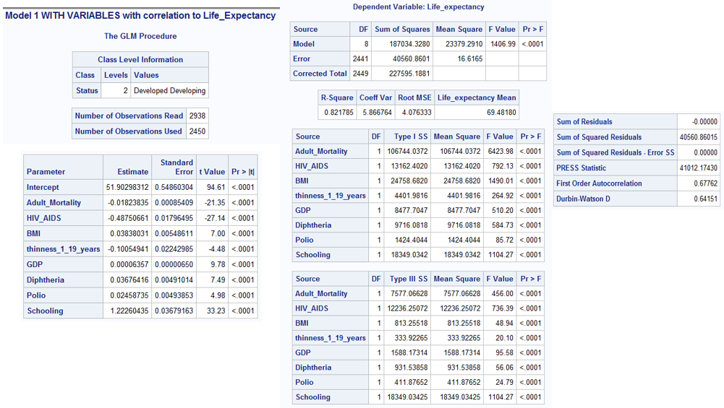

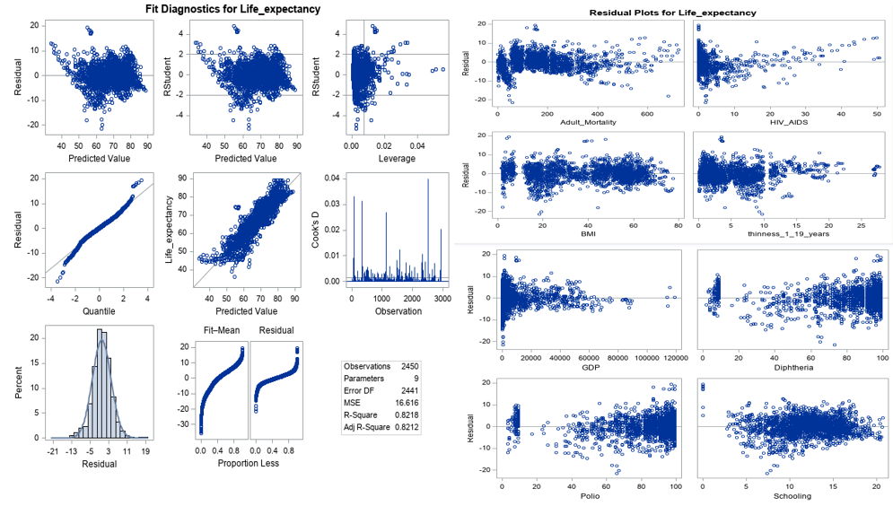

**Model2**: After taking log on Life_Expectancy, HIV_AIDS and GDP.



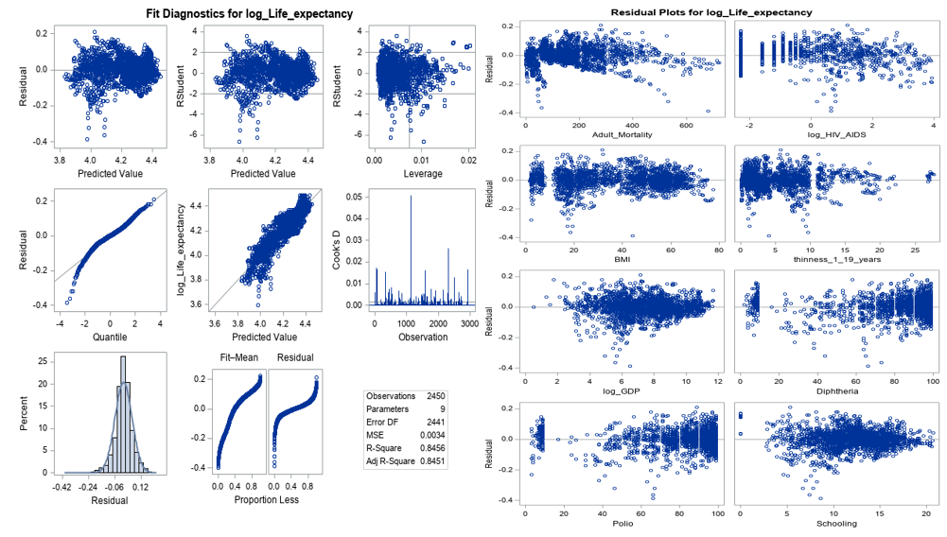

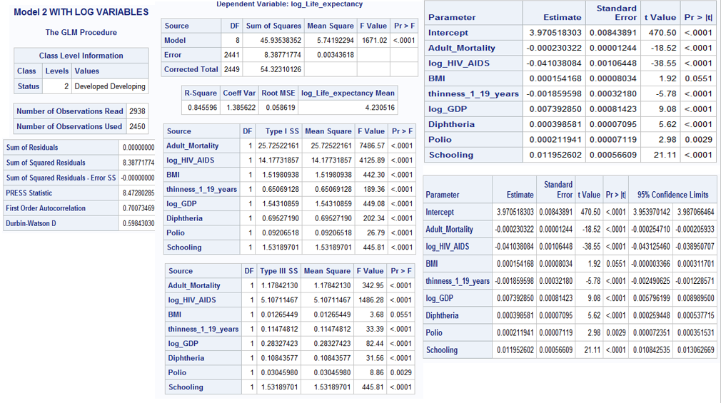

**Revised Model 2:** After taking log transform, BMI becomes statistically insignificant. Revising the model to remove BMI as a model parameter.



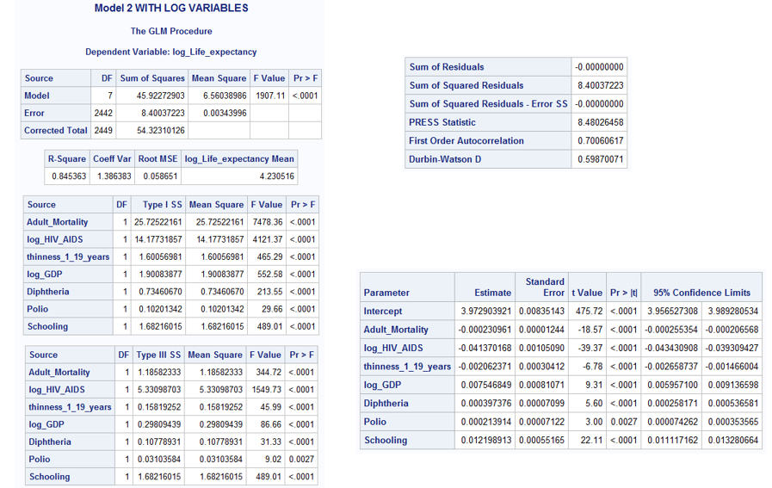

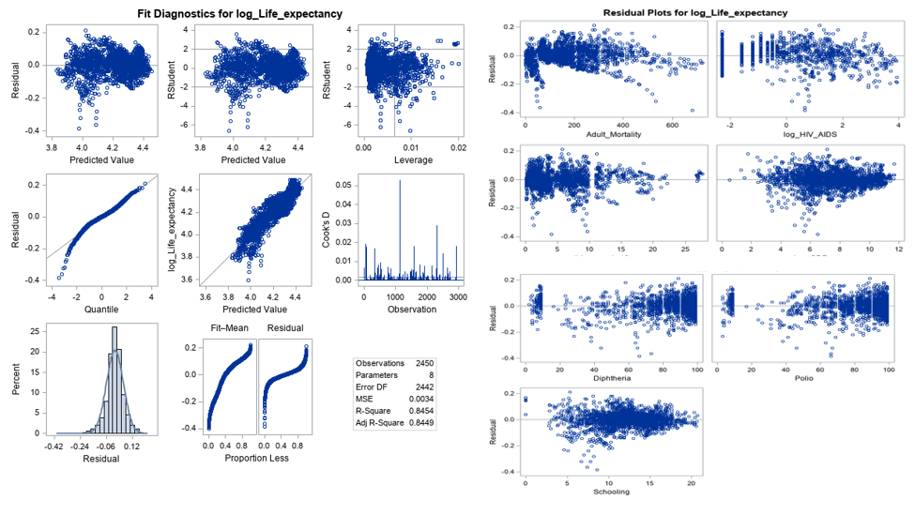

**Finding a complex model: Run models using different feature selection techniques (primarily CV)**

* Model assesment using ASE;

*Run different models using partition fraction(test = .7) and ASEPlots ;

**PROC** **GLMSELECT** DATA= LED plots(stepaxis = number) = (criterionpanel ASEPlot) seed = **1**;

title "**Forward** selection using CV Press as stop criteria with ASE";

partition fraction(test = **.5**);

class Status;

model log_Life_expectancy= Year Adult_Mortality Alcohol log_percentage_expenditure Hepatitis_B log_Measles BMI log_under_five_deaths Polio Total_expenditure Diphtheria log_HIV_AIDS log_Population thinness_1_19_years Income_composition_of_resources Schooling / selection = Forward(stop=CV);

output out = Forwardsel ;

**run**;

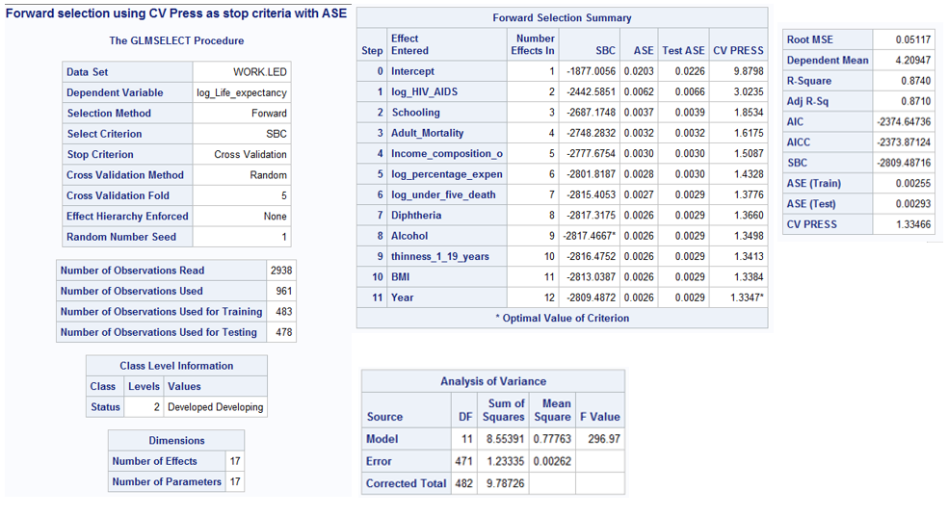

**PROC** **GLMSELECT** DATA= LED plots(stepaxis = number) = (criterionpanel ASEPlot) seed = **1**;

title "**Backward** selection using CV Press as stop criteria with ASE";

partition fraction(test = **.5**);

class Status;

model log_Life_expectancy= Year Adult_Mortality Alcohol log_percentage_expenditure Hepatitis_B log_Measles BMI log_under_five_deaths Polio Total_expenditure Diphtheria log_HIV_AIDS log_Population thinness_1_19_years Income_composition_of_resources Schooling / selection = backward(stop=CV);

output out = Backwardsel ;

**run**;

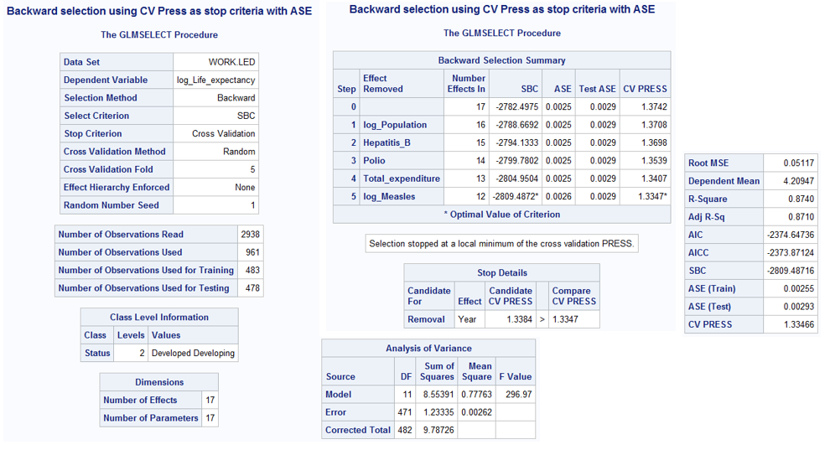

**PROC** **GLMSELECT** DATA= LED plots(stepaxis = number) = (criterionpanel ASEPlot) seed = **1**;

title "**Stepwise** selection using CV Press as stop criteria with ASE";

partition fraction(test = **.5**);

class Status;

model log_Life_expectancy= Year Adult_Mortality Alcohol log_percentage_expenditure Hepatitis_B log_Measles BMI log_under_five_deaths Polio Total_expenditure Diphtheria log_HIV_AIDS log_Population thinness_1_19_years Income_composition_of_resources Schooling / selection = Stepwise(stop=CV);

output out = Stepwisesel ;

**run**;

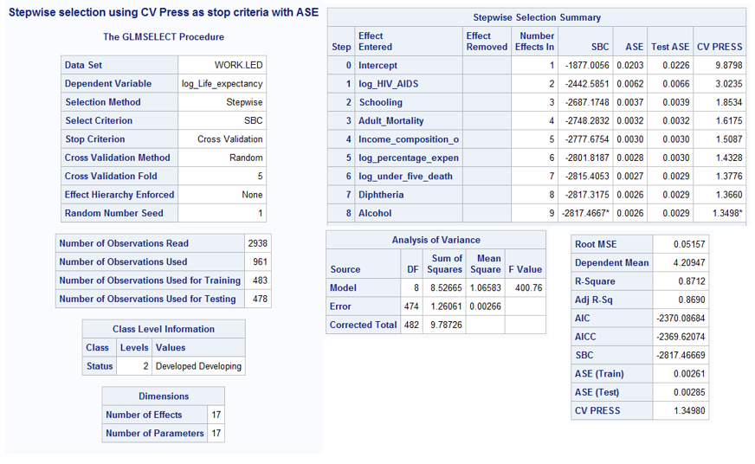

**PROC** **GLMSELECT** DATA= LED plots(stepaxis = number) = (criterionpanel ASEPlot) seed = **1**;

title "**LASSO** selection using CV Press as stop criteria with ASE";

partition fraction(test = **.5**);

class Status;

model log_Life_expectancy= Year Adult_Mortality Alcohol log_percentage_expenditure Hepatitis_B log_Measles BMI log_under_five_deaths Polio Total_expenditure Diphtheria log_HIV_AIDS log_Population thinness_1_19_years Income_composition_of_resources Schooling / selection = lasso( choose = cv) CVDETAILS;

output out = LASSOsel ;

**run**;

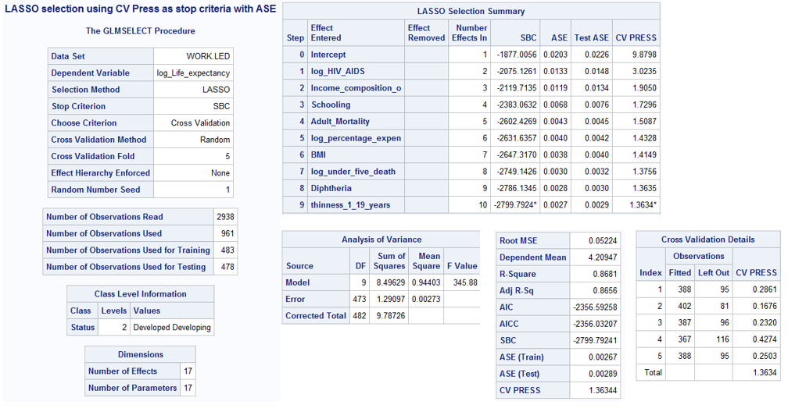

**PROC** **GLMSELECT** DATA= LED plots(stepaxis = number) = (criterionpanel ASEPlot) seed = **1**;

title "**LARS** selection using CV Press as stop criteria with ASE";

partition fraction(test = **.5**);

class Status;

model log_Life_expectancy= Year Adult_Mortality Alcohol log_percentage_expenditure Hepatitis_B log_Measles BMI log_under_five_deaths Polio Total_expenditure Diphtheria log_HIV_AIDS log_Population thinness_1_19_years Income_composition_of_resources Schooling / selection = lars( choose = cv) CVDETAILS;

output out = LARSsel ;

**run**;

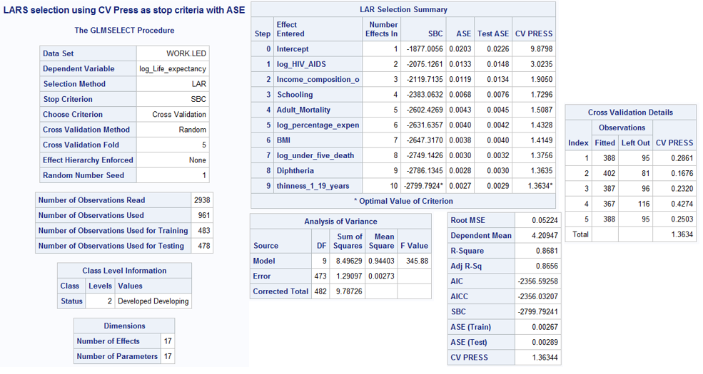

Both, Forward and Backward, selection methods have the least CV PRESS and ASE -Train and Test. Looking at the variables selected by each of the models, I will go ahead with the creating a custom model using the variables selected by ‘Forward selection’.

Custom Model:

**PROC** **GLM** DATA= LED plots = all;

title "Custom Model with variables selected from Forward model with STATUS interaction ";

class Status;

model log_Life_expectancy = log_HIV_AIDS Schooling Adult_Mortality Income_composition_of_resources log_percentage_expenditure log_under_five_deaths Diphtheria Alcohol thinness_1_19_years BMI log_HIV_AIDS*Status Schooling*Status Adult_Mortality*Status Income_composition_of_resources*Status log_percentage_expenditure*Status log_under_five_deaths*Status Diphtheria*Status Alcohol*Status thinness_1_19_years*Status BMI*Status / solution clparm ;

output out = Customsel ;

**run**;

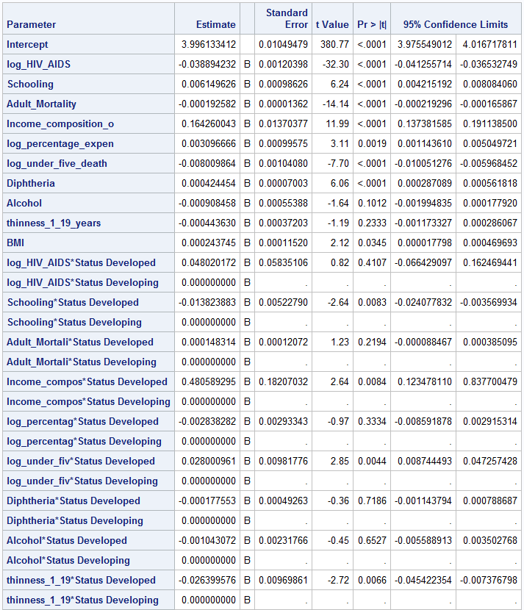



Removing all the statistically insignificant variables from the model:

**Revised Customer Model**

**PROC** **GLM** DATA= LED plots = all;

title "Custom Model with variables selected from Forward model with STATUS interaction ";

class Status;

model log_Life_expectancy = log_HIV_AIDS Schooling Adult_Mortality Income_composition_of_resources log_percentage_expenditure Diphtheria Income_composition_of_resources*Status / solution cli clparm ;

output out = Customsel ;

**run**;

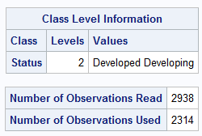

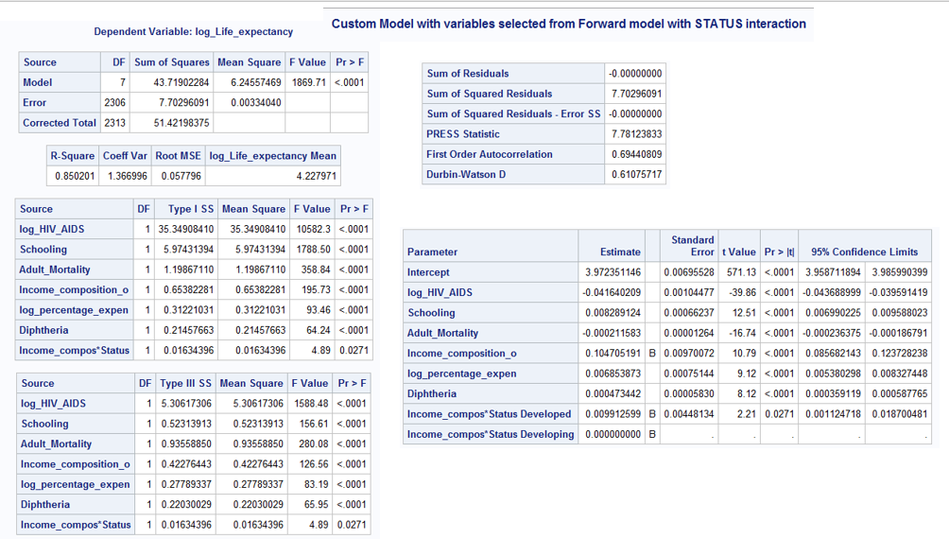

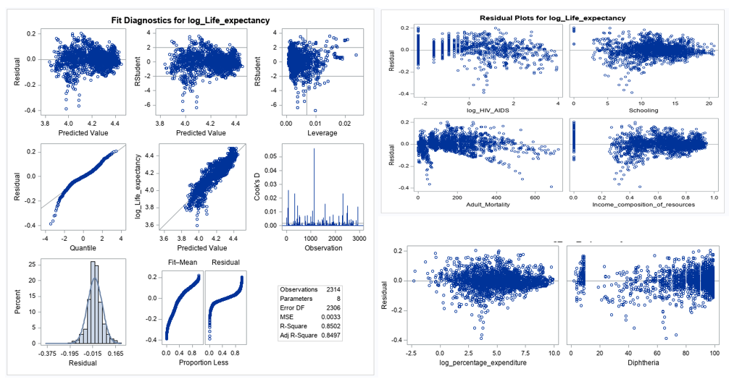

MODEL 3: Getting the ASE Plots

**PROC** **GLMSELECT** DATA= LED plots(stepaxis = number) = (criterionpanel ASEPlot) seed = **1**;

title "Forward selection using CV Press as stop criteria with ASE";

partition fraction(test = **.5**);

class Status;

model log_Life_expectancy = log_HIV_AIDS Schooling Adult_Mortality Income_composition_of_resources log_percentage_expenditure Diphtheria Income_composition_of_resources*Status / selection = Forward(stop=CV)CVDETAILS;

output out = Forwardsel ;

**run**;

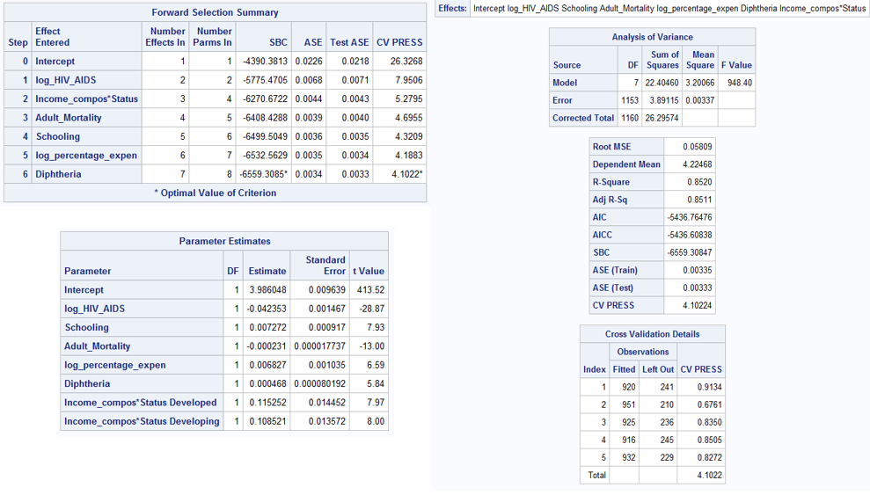

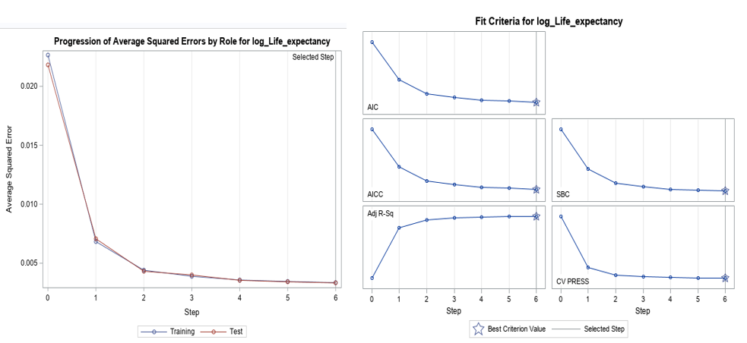

Outlier Analysis:

Outlier Analysis using all the variables in Model3: We see obs. 1128 has a very high cook’s D.

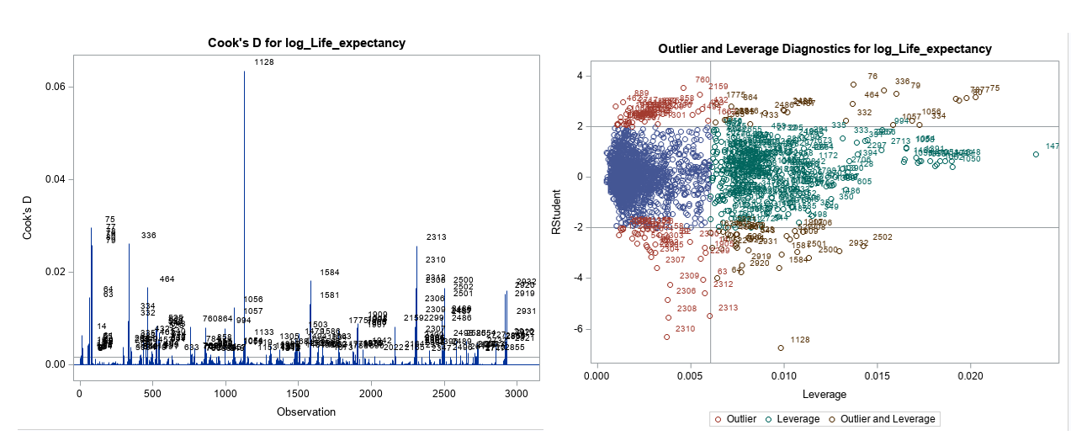

Analysis after removing obs. 1128 from the data set:

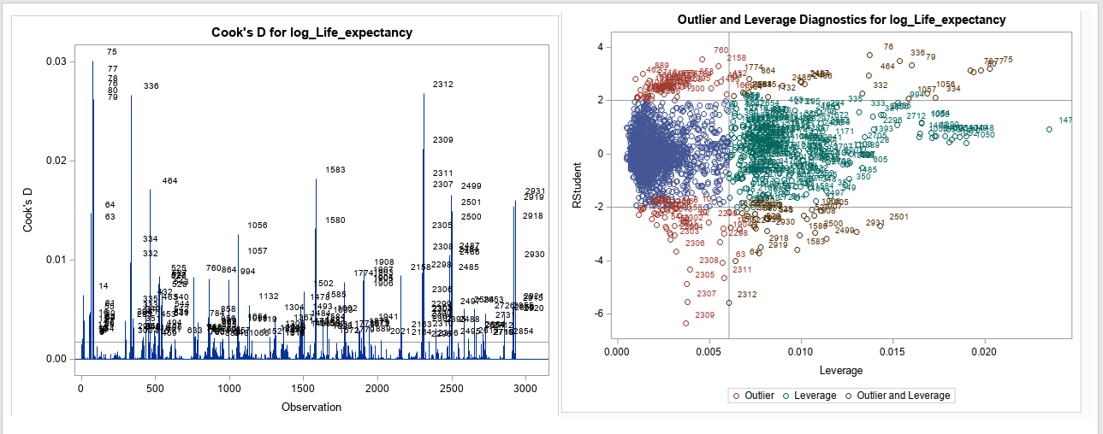

Running model3 after removing obs. 1128 did not impact the model. So we could keep the obs. 1128 in the data set.

Objective 2

Knn

KNN does not allow any missing variables, hence use all cleansed data set.